**SQL Homework**

*1.Create two Tables in DB*

*The first one has IDnumber, FirstName, LastName,*

*Second One has ID Order Number*

CREATE DATABASE Customer;

USE Customers;

CREATE TABLE CustomersList (

CustomersID int,

FirstName varchar(255),

LastName varchar(255)

);

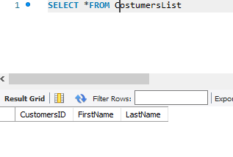

CREATE TABLE Orders (

ID int,

OrderNumber int

);

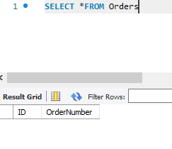

*2.Have CustomersID in the first table which is not available in the second table*

INSERT INTO CustomersList (CustomersID, FirstName, LastName)

VALUES ('01', 'Lilit', 'Vardanyan');

('02', 'Lusine', 'Sargsyan');

('03', 'Artur', 'Davtyan');

('04', 'Hasmik', 'Karapetyan');

('05', 'Shushan', 'Tovmasyan');

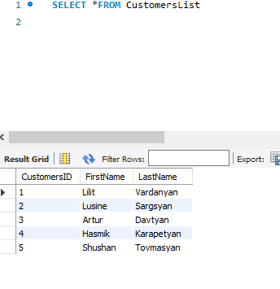

*3.Have CustomersID in second table which is not in the first table*

INSERT INTO Orders (ID, OrderNumber)

(4, 2020);

(8, 2023);

(2, 2043);

(66, 2088);

(6, 2025);

(1, 2024);

(11, 5555);

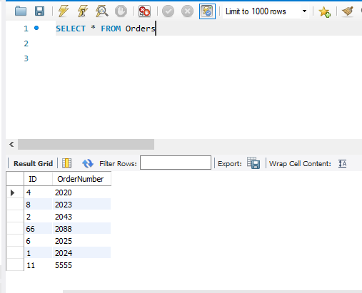

*4. Inner join*

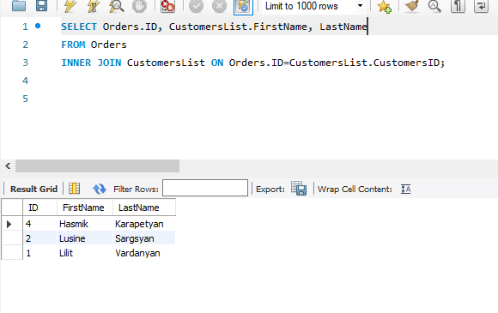

*5. Left Join*

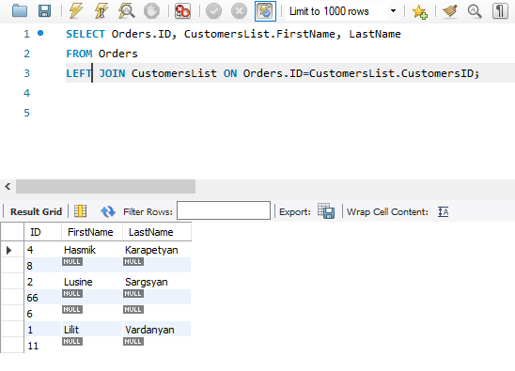

*6.Right Join*

